Business model canvas

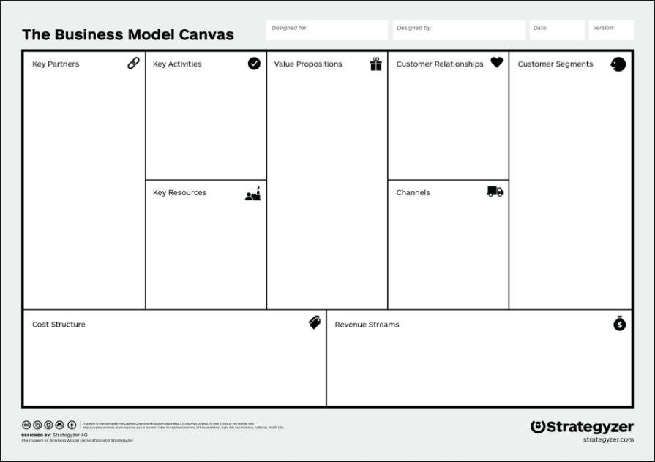

Sections:

Key Partners – Who are the key partners? Who are our key suppliers? What resources are we acquiring from partners? What activities do partners perform?

Key Activities – What activities do our value propositions require? Distribution channels? Customer relationships. Revenue streams.

Key Resources – What key resources do our value propositions require? What does distribution require? What do customer relationships require? What do revenue streams require?

Cost Structure – What are the most important costs for our business model? Which resources are most expensive? Which activities are most expensive?

Value Propositions – What’s the value to the customer? What problem for our customer are we solving? What products/services are we offering? What customer needs do we satisfy? What is the minimum viable product?

Customer Relationships – How do we get, keep, and grow customers? Which customer relationships have we established? How are they integrated with the rest of our business model? How costly are the customers?

Channels – How do we reach out to and communicate with customers? How do other companies reach our customers? Which methods of communication work best? Which methods are most cost-efficient? How are we integrating them with customer routines?

Customer Segments – For whom are we creating value? Who are our most important customer? What are the customer archetypes?

Revenue Streams – For what value are our customer willing to pay? What do they currently pay for similar products? What is the revenue model (how do we get money in)? What are the pricing tactics?